



Ordinarily Available Provision
School: Lincroft Academy

What it is and what we do.
Coproduced with our SENDCo Network.

Contents

Vision & Mission Page 3

Meridian, an Inclusive & Equitable trust Page 4

Timely Identification & The Graduated Approach Page 5

This document Page 6

Part 1.1: Valuing People Page 7

Part 1.2: High Quality Learning Environments Page 10

Part 1.3: Pursuit of Excellence Page 13

Part 1.4: Extending the Boundaries Page 15

Part 1.5: Learning & Achievement for All Page 18

Part 2: Areas of Need Page 22

Part 2.1: Cognition & Learning Needs Page 23

Part 2.2: Communication & Interaction Needs Page 30

Part 2.3: Social Emotional & Mental Health Needs Page 37

Part 2.4 Sensory and/or Physical Needs Page 44

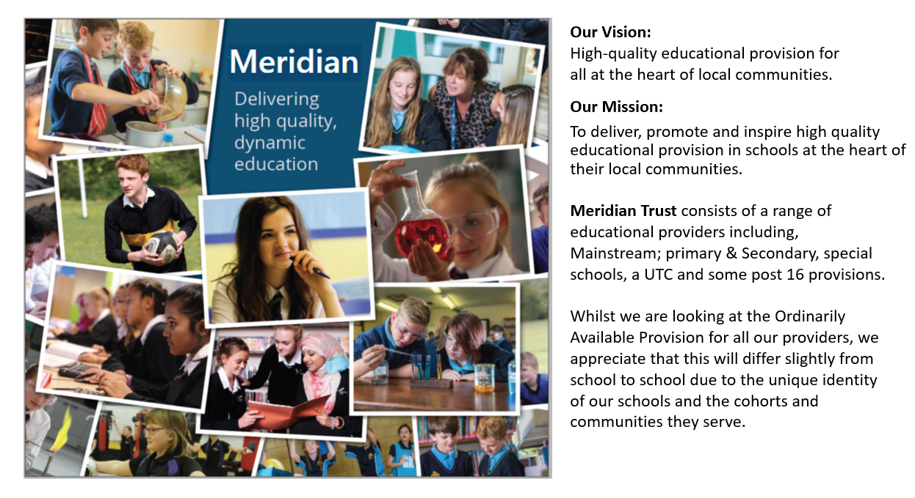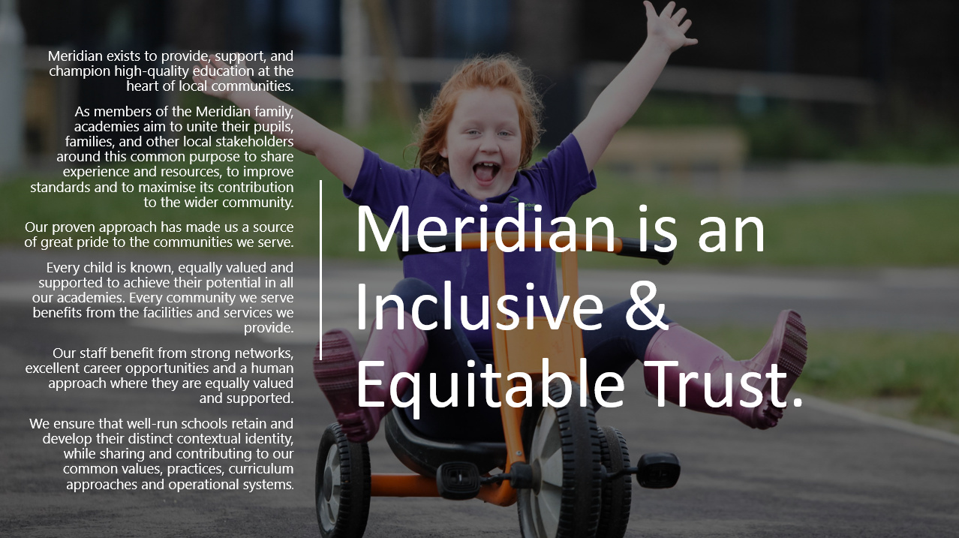

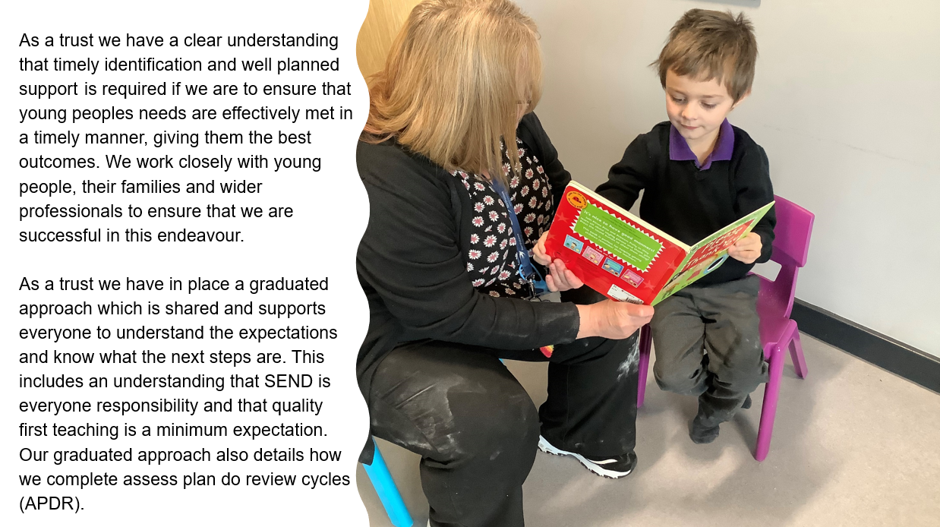
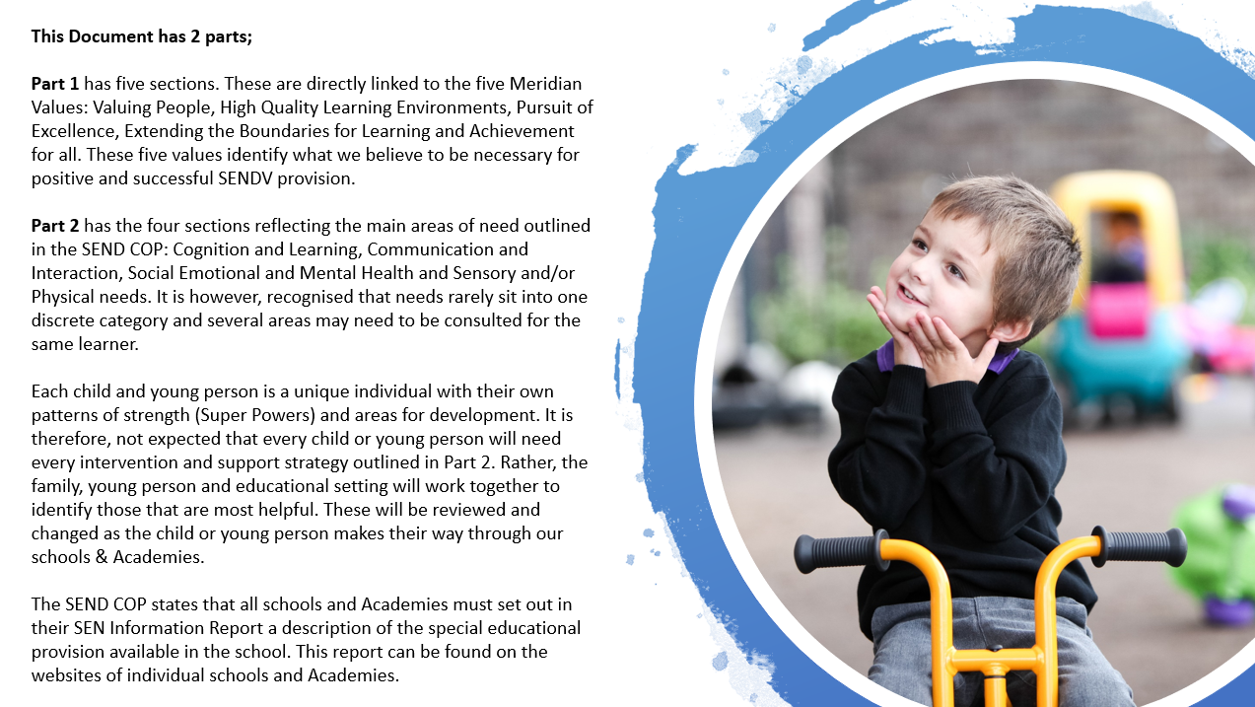
Part 1.1: Valuing People

What? | Why? | How? | So What?
The Code of practice highlights that coproduction is key and rightly states that we should include CYP and their families in all decisions. | The best support for CYP with SEND/V is based on a positive partnership between home and the setting. | - Parents and families are aware of the many ways in which they can share information about their child and know that this will be heard.  - Regular meetings are planned to review the progress and to make decisions with the family and all concerned, including wider professionals if this is appropriate.  - A range of communication techniques are used to appropriately share information.  - Parents are aware of:  - the Needs of their CYP;  - the support in place;  - and are involved in setting and reviewing targets and outcomes as part of a sound coproduction approach.  - Parents and carers are signposted to the local offer of the local area in which the setting is situated.  - The school SEND information report is published on the school’s website. | - Parents and families are confident in the provision which is available to the CYP.  - Planning meetings are effective and coproduced. They help staff to ensure that they are effective in meeting need.  - Parents are well informed, and value being seen as experts by experience  - Parents know where the local offer is and how to use it.  - SEND information reports accurately reflect what is available and parents can use them to make informed choices.
An effective partnership with learners and parent/carers is evident. (This will vary in nature depending on the age of the CYP). | To ensure everyone is aware of the CYP needs, strengths and progress.  To ensure participation in assessment and review processes. | - Learners are involved in the graduated approach. They assess, plan, do and review their learning.  - Learners are helped to value their progress and achievements and to recognise and understand their own barriers to learning.  - Learners understand, identify and contribute towards the targets they intend to achieve.  - The APDR Support Plan should be used to document the assess, plan, do, review approach. | - The graduated approach enables staff to understand what the expectations are.  - CYP & staff celebrate their own success.  - The voice of the CYP is heard and understood.
The setting has a clear system for pastoral support. | Learners with SEND can be (but are not always) vulnerable to, for example, bullying. Therefore, an appropriate level of supervision and support is required. CYP need to know who they can turn to for support. | - Awareness and sensitivity of peers and staff towards difference (SEND) is raised at a whole setting level. Focussed work is planned for classes and groups regarding specific needs or conditions where necessary.  - A calm learning environment is created by and for all staff and CYP.  - All staff need to know the pupils in their care with SEND. They need to know how best to support the CYP and their strengths. They also need to know which key person is supporting the CYP.  - All Staff need to be aware of trauma informed practices and relationship-based approaches to behaviour.  - Language in the classroom demonstrates unconditional positive regard for learners (restorative approaches and relationship - based approaches). | - Difference is not just acceptable but valued.  - Learning environments are a good place to be.  - Every child is known and valued.  - Effective support is understood at and individual level.  - The right support is in place.  - Therapeutic thinking is at the bottom of what we do.
The setting recognises and responds to the need for individual pastoral support for learners with SEND bearing in mind the individual’s social, emotional needs and any other relevant circumstances such as adverse childhood experiences. | Sometimes CYP with SEND have other needs or circumstances that require sensitive support. | - Named adults are available as key workers when required. Within ordinarily available provision this could be a family link worker, tutor, lunch time supervisor, peer mentor, learning mentor or classroom assistant.  - CYP can identify a space of safety and are able to use the space when required. | - Access to the adults who help is available.  - CYP feel safe and are safe.
Learners feel safe and valued in the setting. They know that they can talk to staff who will listen to concerns and value their opinions. | Learners with SEND can be (although are not always) vulnerable. They may also find it more difficult to communicate with staff and peers. | - Negative attitudes, beliefs or practices towards individuals or groups are challenged. This should happen in the classroom, across the wider setting.  - CYP’s voices are encouraged through, for example, student councils, pupil representatives, good idea boxes, photographs. | - There is a reduction in the incidents of negative practice.  - CYP voices are heard and acted upon.
An effective partnership with learners and parent/carers is evident. (This will vary in nature depending on the age of the CYP). | To ensure everyone is aware of the CYP needs, strengths and progress.  To ensure participate in assessment and review processes. | - Learners are involved in the graduated approach. They assess, plan, do and review their learning.  - Learners are helped to value their progress and achievements and to recognise and understand their own barriers to learning.  - Learners understand, identify and contribute towards the targets they intend to achieve. | - The graduated approach enables CYP to understand what the expectations are.  - CYP & staff celebrate their own success.  - CYP aspirations are valued.

Part 1.2: High Quality Learning Environment

What? | Why? | How? | So What?
The physical environment is adapted to meet the needs of learners. | Some CYP with SEND experience challenges in accessing the physical learning environment for a variety of  different reasons.  Educational settings need to think proactively if learning is accessible to all and what reasonable adjustments can be made. | - The physical accessibility of the building and individual learning spaces is assessed. The accessibility plan is on the setting website and reasonable adjustments are made according to individual needs.  - The furniture is the appropriate size/ height for the learners.  - Extra-curricular activities and educational visits are planned to fully include pupils with SEND (in line with the Equalities Act 2010), including those with SEMH and physical disabilities. Reasonable adjustments are made.  - Learners’ views are routinely sought and are used to inform in planning for physical or sensory adaptations that they may require.  - The classroom needs to be accessible to those with sensory impairment – visually friendly (good contrast, lighting, reduced glare, blinds to control light etc.) and deaf friendly (acoustics) such as sitting near the speaker, a reduction in background noise by closing doors.  - Equally access to WIFI and use of IT systems which support the use of assistive technology. | - The accessibility plan is an enabling document.  - Physical equipment is made available to ensure access.  - CYP who have SEND are able to join their peers on trips and visits, there is a culture of no one missing out.  - Adaptations are made in response to what CYP tells us they need.  - Assistive technology is available and can be used effectively.
Practitioners are aware of sensory needs and issues that may impact on learners. | Some CYP with SEND have sensory impairments such as hearing or visual impairments.  Many autistic people also have sensory issues. This can affect one or more of the senses and they can be either over-developed (hypersensitive) or under-developed (hyposensitive). Both can have an impact on how people experience different environments. | - Learners’ sensory needs are known and used to plan seating arrangements and movement breaks.  - Left and right-handed CYP can use equipment comfortably.  - CYP who wear glasses and/ or hearing aids wear them and are seated in the optimum position.  - Displays are meaningful and visually accessible to reduce sensory overload. For example, muted tones could be used with simple and clear text.  - Staff are aware of lighting in the room, for example, use of natural light, glare from the board, who is facing the light, where you stand in relation to the light.  - Use of pale background and accessible font styles on the whiteboard.  - Staff are aware of smells and noise in the room and any individuals who may be impacted by these (for example, a classroom next to the canteen or music rooms). Simple steps such as keeping doors closed can reduce the impact. | - Planning enables CYP to be engaged and effective in their learning.  - Sensory needs are known and met.
Resources are allocated appropriately to ensure additional needs are met and are redirected to others where necessary. | Interventions that have been effective in the past need to be updated as CYP matures and develops new skills. | - Resources are within easy reach of learners to promote the reduction of dependence on adults.  - Learners have easy access to sensory equipment that they require, for example, writing slopes, pencil grips, wobble cushions, fidget toys, ear defenders, and weighted blankets. | - CYP reduced dependency on adults is encouraged as preparations for adulthood.  - Equipment is where it needs to be.
Quality and impact of support, is scrutinised. | Therefore, it is important to redirect support and equipment ensuring that it is available for those who will make best use of it. | - Resources are clear and uncluttered, labelled using text and images. Print size and font is appropriate.  - Coloured backgrounds and paper are used to reduce visual stress.  - Adapted physical resources such as PE and Maths equipment are adapted to promote independence for example, different size balls. | - Resource requirements are known, and resources are therefore available.
Specific resources and strategies are provided to overcome potential barriers to learning. Increased use of appropriate and supportive ICT resources. | Not all interventions work for all CYP. Therefore, we need to use research and  evidence to predict the strategies that may work best for CYP with specific needs.  Interventions often require adapting for individual needs but will need to be based in evidence informed practice. | - Concrete apparatus and adapted resources are available for those CYP who require it.  - ICT is used to support alternatives to written recording and to promote independent learning.  - Research evidence is used to ensure that we are using evidence informed practices. | - Staff know what CYP need to be successful and make it available.  - The reduction of dependency on adults is always encouraged.  - Staff know what works and why.

Part 1.3: Pursuit of Excellence

What? | Why? | How? | So What?
All practitioners, including Teaching Assistants, make a positive contribution to learner progress. | Unfocussed support is difficult for CYP with SEND and the additional adult. Targeted adult support through interventions is most likely to achieve positive progress. | - Additional adults are deployed proactively in the classroom in a clear planned way with identified learning objectives and success criteria; their impact on the learner is monitored carefully to ensure progress is supported.  - Grouping, seating arrangements and additional support are used to promote reduced dependant learning as far as possible.  - Strategies used in interventions are integrated into typical teaching so that they can sustain progress. For example, if a visual timetable approach has been helpful for an individual, this could be incorporated into whole class teaching and routines.  - Leaders in settings consider the deployment of additional adults strategically. | - CYP are well supported by the adults around them, but these adults allow for the reduction in dependence on them.  - There is an increase of ordinarily available strategies for support.  - Staff know how and when to use strategies.  - Staff are in the right place at the right time.
There is a plan for on-going Continuing Professional Development (CPD) in relation to the needs of the learners. | Developments in strategies and  interventions for CYP with SEND are on-going.  All staff who work in education need to keep up to date with developments. | - There is a planned programme of ongoing CPD in relation to SEND for the whole setting and individual teams and departments.  - Best practice is shared within the setting and with other settings through, for example, trust SENCO Network meetings. | - Staff are well trained to effectively meet need.  - Staff know where practice is best, this is celebrated and shared.
Staff collaborate and have effective links with other relevant outside agencies and specialists. | Educational settings have a vast range of expertise and skills that can be shared in and across settings. However, where staff have continued concerns, leaders liaise with outside agencies and specialists for further ideas, support and training. | - Initially, this will be support internal to the setting and if concerns continue, external support can be sought.  - The setting is aware of and regularly communicates with any other professionals who are involved with each learner.  - Advice received from other professionals is used to inform teaching and learning and can be seen in pupil planning documents.  - Where specific decisions to involve outside agencies in casework are made this will be in partnership with parent/carers. | - Help for staff is available in school and at trust level.  - Professionals are fully involved.  - Parents are included in decisions about which professionals are involved.

Part 1.4: Extending the Boundaries

What? | Why? | How? | So What?
All practitioners, including Teaching Assistants, make a positive contribution to learner progress. | Unfocussed support is difficult for CYP with SEND and the additional adult. Targeted adult support through interventions is most likely to achieve positive progress. | - Additional adults are deployed proactively in the classroom in a clear planned way with identified learning objectives and success criteria; their impact on the learner is monitored carefully to ensure progress is supported.  - Grouping, seating arrangements and additional support are used to promote independent learning as far as possible.  - Strategies used in interventions are integrated into typical teaching so that they can sustain progress. For example, if a visual timetable approach has been helpful for an individual, this could be incorporated into whole class teaching and routines.  - Leaders in settings consider the deployment of additional adults strategically. | - Staff are in the right place, offering the right support and it makes a difference to CYP progress.  - Students are given the room to work without the support of adults where appropriate.  - Strategies used improve progress.  - Staff are deployed appropriately and make a difference.
There is a plan for on-going Continuing Professional Development (CPD) in relation to the needs of the learners. | Developments in strategies and  interventions for CYP with SEND are on-going.  All staff who work in education need to keep up to date with developments. | - There is a planned programme of ongoing CPD in relation to SEND for the whole setting and individual teams and departments.  - Best practice is shared within the setting and with other settings through, for example, SENCO Network meetings. | - Staff are well trained and, as a result, effectively meet need.
Staff collaborate and have effective links with other relevant outside agencies and specialists. | Educational settings have a vast range of expertise and skills that can be shared in and across settings. However, where staff have continued concerns, leaders liaise with outside agencies and specialists for further ideas, support and training. | - Initially, this will be support internal to the setting and if concerns continue, external support can be sought.  - The setting is aware of and regularly communicates with any other professionals who are involved with each learner.  - Advice received from other professionals is used to inform teaching and learning and can be seen in pupil planning documents.  - Where specific decisions to involve outside agencies in casework are made this will be in partnership with parent/carers. | - Staff work well together to enable progress to be made.  - All professionals communicate well and share ideas.  - Plans reflect these ideas.  - Parents are confident decisions are made with them.
Support is in place for routine and life transitions when required. | Change can be difficult, and support may be needed to transfer to another setting, learning space or between lessons. | - Staff are aware of those who will need additional support for all or most transitions and plan for these transitions. This includes learners who:  - have insecure attachment including but not limited to LAC, CIN, CP and forces pupils;  - have social communication difficulty including ASC, suffered trauma, loss or bereavement, are anxious.  - Transitions include:  - Moving around the setting  - Preparing for weekends and the start of holidays and beginning of term  - Moving from lesson to lesson  - Changing from structured to unstructured times  - Moving from break to lesson times  - Moving from one activity to the next within a lesson  - Changes of staff -permanent and temporary  - Special events: visitors, visits, celebrations  - Life events: birth of a sibling, change in parenting arrangements for example, change in parents’ relationship status, loss and bereavement or contact visits, puberty.  - Safe space available within the classroom or an identified area of the setting  - when needed. Plans are also made for unstructured times: there are structured alternatives such as games club, use of library for vulnerable CYP.  - Visual timetables are used.  - Where appropriate, timers are used to show pupils how long they have left to work and how long until a finish time. | - Support is put in place in a timely way.  - Transitions are thoughtfully planned and effectively support CYP.

Part 1.5: Learning and Achievement for All

What? | Why? | How? | So What?
Practitioners are aware of the additional needs of their learners; understand the nature and impact of these and how to respond to them.  Planning incorporates more detailed specialist advice. | Some CYP with SEND respond well to generic teaching approaches to classroom teaching. A timetable can, for example, be shown visually as well as verbally. | - Aspects of structured teaching are used according to pupil needs, for example, visual timetables, clear concise instructions with written or visual prompts (for example, now and next cards), particularly during transitions.  - An auditory prompt such as music or a musical sound such as a rain maker can be paired with a visual cue to support transition from one activity to another.  - Learners are given time to process information before being asked to respond.  - Tasks are broken down into small manageable steps. These steps are shown explicitly.  - Feedback is clearly identified as being key to learning.  - The pace and order of activities is varied to maintain interest and attention of all CYP.  - Specialists are asked to work alongside educational setting staff to support the assess, plan, do, review process at SEND support. | - The right support is in place.  - Staff give strategies and support structures time to work.  - Planned support breaks down tasks to ensure CYP can do them.  - CYP enjoy learning and can keep up.
Practitioners differentiate to provide suitable learning challenges and cater for different learning needs.  Individualised and/or small group planning and programmes in more than one curriculum area.  Use of goal setting to promote independence, scaffold and support learners. | Some CYP with SEND respond well to generic approaches to classroom teaching. For example, teachers can differentiate tasks by outcomes: expecting some to draw their answers or some to answer more questions than others. | - Modelling is used to aid understanding.  - Visual/audio demonstrations and visual cues/audio commentary are used.  - Key vocabulary is displayed with visuals.  - Alternatives to written recording are used routinely.  - Study skills are explicitly taught. Pupils have access to homework clubs, or additional support with homework.  - Homework is differentiated appropriately for pupils.  - Teachers’ handwriting on the board and in pupils’ books is clear and legible.  - Interactive whiteboard (or other teaching boards such as flip charts) are used effectively to promote engagement and scaffold the lesson.  - IT is used to support learning where appropriate. | - The learning environment help CYP learn.  - No one method is relied upon, so all CYP can access.  - Homework is well planned and includes support.  - CYP are engaged and enjoying learning.
Practitioners ensure that learners have opportunities to work in different ways, for example, independently, in small groups and/or in pairs.  Individualised and/or small group sessions are also used. | Some children with SEND respond to having additional adults working in the classroom. However, this can lead to a delay in the development of independence skills.  Where additional adults are available their work should be planned with care to ensure that the independence skills of the CYP are maximised. | - Teaching strategies are used to actively promote independent learning, for example, through pre-teaching, overlearning, appropriately differentiated resources.  - Seating plans and groupings take account of individual needs and routinely provide opportunities for access to role- models, mixed-ability groups, structured opportunities for conversation and sharing of ideas, with access to additional adults where they are available.  - Use of additional adults is planned to maximise their impact on learning.  - Additional adults are used to support independence rather than create dependence. | - Support means that CYP can reduce the dependence they have on the adults around them.  - CYP needs are well considered when deciding where they should sit and who they should work with or alongside.  - The right adults offer the right amount of support.  - Dependence on adults is reduced.
Practitioners ensure that collaborative learning and peer support is a feature of all lessons. | Some CYP with SEND also have difficulties in making and maintaining friendships. Getting along with others is  a key skill needed in adult life. | - Strategies that foster collaboration and working together with positive regard are used to support teaching and classroom relationships.  - Strategies are used to build and maintain positive relationships across the whole community (for example, peer mentoring).  - There are opportunities to develop peer awareness and sensitivity and support for different needs and disabilities both in and out of the classroom. | - Working together for best outcomes is just what we do.  - Positive relationships are the norm.  - Peers understand need and adjustment.  - We know why CYP behaviour in a particular way.  - We know how to manage difficult behaviour.
To use the assess, plan, do and review cycle. | To ensure that appropriate planning is in place for CYP with SEND. To ensure appropriate provision and interventions are in place for CYP  with SEND.  To ensure that CYP with SEND are making progress. To ensure individual CYP’s development trends are considered as well as general developmental milestones. | - The learning and behaviour of CYP is monitored and observed in different settings, contexts and times across the day for short periods to inform assessment, planning and review.  - Staff are aware of CYP starting points so that progress can be measured at each phase or key stage.  - Assessment is used to inform planning and interventions and assessment  - is undertaken through observing performance during interventions. | - We know what precedes behaviours that challenge.  - Staff use their knowledge to plan interventions or support strategies.
All practitioners, including Teaching Assistants, make a positive contribution to learner progress. | Unfocussed support is difficult for CYP with SEND and the additional adult. Targeted adult support through interventions is most likely to achieve positive progress. | - Additional adults are deployed proactively in the classroom in a clear planned way with identified learning objectives and success criteria; their impact on the learner is monitored carefully to ensure progress is supported.  - Grouping, seating arrangements and additional support are used to promote independent learning as far as possible.  - Strategies used in interventions are integrated into typical teaching so that they can sustain progress. For example, if a visual timetable approach has been helpful for an individual, this could be incorporated into whole class teaching and routines.  - Leaders in settings consider the deployment of additional adults strategically. | - Adults who support CYP make a difference.  - The reduction of dependency on adults around them supports CYP to be as independent as possible.  - Strategies which are know to work are used.
There is a plan for on-going Continuing Professional Development (CPD) in relation to the needs of the learners. | Developments in strategies and  interventions for CYP with SEND are on-going.  All staff who work in education need to keep up to date with developments. | - There is a planned programme of ongoing CPD in relation to SEND for the whole setting and individual teams and departments.  - Best practice is shared within the setting and with other settings through, for example, SENCO network meetings. | - Staff are well trained and are effective in their support for CYP.  - Staff know and use best practice.
Staff collaborate and have effective links with other relevant outside agencies and specialists. | Educational settings have a vast range of expertise and skills that can be shared in and across settings. However, where staff have continue concerns, leaders liaise with outside agencies and specialists for further ideas, support and training. | - Initially, this will be support internal to the setting and if concerns continue, external support can be sought.  - The setting is aware of and regularly communicates with any other professionals who are involved with each learner.  - Advice received from other professionals is used to inform teaching and learning and can be seen in pupil planning documents.  - Where specific decisions to involve outside agencies in casework are made this will be in partnership with parent/carers. | - The right support is used at the right time.  - Coproduction with all professionals and the family are central to what staff do.  - Effective planning for need means that progress is made.

Part 2: COP Areas of Need

This chapter has been divided into four areas as set out in the SEND Code of Practice: cognition and learning, communication and interaction, social emotional and mental health and physical and sensory needs. CYP have needs that are diverse and interconnected therefore practitioners need to look across all four areas to ensure they are addressing all identified needs. As mentioned in the introduction section, each child and young person is a unique individual with their own pattern of strengths and areas for development (Super Powers). It is therefore not expected that every child or young person will need every intervention and support strategy outlined in this chapter. Rather, that the family, young person and educational setting will work together to identify those most helpful at any time. These will be reviewed and will change as the child or young person makes progress, grows, develops and matures.

Prior to detailing the four areas of the SEND COP, the paragraph below discusses ordinarily available provision for CYP with medical conditions.

Medical Conditions
CYP with medical needs can be supported in all educational settings, even CYP with the most significant medical conditions. Some children with medical conditions will need individual health care plans. This is not the same as an Education, Health and Care Plan.

An individual health care plan is particularly for those who may need emergency treatment in a setting (such as CYP with epilepsy, diabetes or anaphylaxis). An individual health care plan documents a child or young person’s medical needs and gives advice to teaching staff about how their medical condition should be managed in a setting and during activities. Settings can then ensure that the appropriate type and level of support is available. The school nursing service can support with the writing of these plans and support teaching staff to access specialist medical advice where relevant.

If a young person has a medical need (and does not have additional special educational needs) then an individual health care plan is enough support. Sometimes this can be confused with the need for an EHCP. Individual health care plans are part of what is ordinarily available as part of the setting-based stages of the SEND COP.
Part 2.1: Cognition and Learning

Strategies
- Differentiation to ensure the development of literacy, numeracy, expressive language, communication skills, minimise unhelpful behaviour and emotional difficulties and promotion of appropriate interpersonal skills with other students.
- Arrangements to support the use and delivery of approaches/materials for CYP with Specific Learning Difficulties (SpLD) which may include, a focus on phonological awareness or motor skills programme.
- Effective use of IT equipment to support learning.
- Practitioners and Teaching Assistants are trained and skilled in supporting CYP with general and specific learning difficulties. They are trained in the effective use of feedback and mediated learning.

Resources, Advice and Consultation available
- Educational Psychology consultation for individuals or groups.
- Virtual School consultation for the learning and progress of children in care.
- Code Read intervention based on NGRT assessment in the academy.
- Evidence based interventions information from Education Endowment Foundation
educationendowmentfoundation.org.uk/
- Consultation with SEND Specialist Leaders in Education.
- NASEN: www.sendgateway.org.uk
- Achievement For All: www.afa3as.org.uk
- The Dyslexia Trust: www.thedyslexia-spldtrust.org.uk

Need | - How we support | So What?
Difficulties with learning. For example, despite appropriate differentiation CYP are making inadequate progress over time across the curriculum and working below age related expectations. | - Awareness of how much information a CYP is able to retain.  - Personalised visual timetable.  - Visual cues and prompts.  - Assessment through observation or teaching to identify the areas of need in consultation with the learner.  - Whole setting C&I awareness training.  - Clear and simple instructions, breaking down longer instructions and giving one at a time. Scaffolding and modelling. Use of questioning. Oracy, talk partners, articulating learning.  - Pre-teaching, for example, provision of an intervention to help prepare the learner for the new topic.  - Differentiated resources. For example, teach the curriculum appropriate to the needs of the CYP not to a chronological age, but rather working to close any gaps.  - Chunking, cognitive load and working memory supported (make it explicit that this is the basis for provision in this box?)  - Social Stories.  - Give time before response is needed.  - Use of finely grained standardised reading, spelling and numeracy tests to understand learning needs and to measure progress. This could also be the Differentiated Early Year’s Outcomes framework (DEYO). A whole setting vocabulary approach and focus on the impact of speech and language on learning including whole staff knowledge and awareness of communication milestones.  - Collecting pupil voice around CYP perception of how they are doing/coping- Pupil Profiles accurate, up to date, shared with staff. Time spent 1:1 with CYP to collect their input.  - Consideration of EAL- level of fluency in home language.  - Clear information about time missed from education and the knock-on effect of this- attendance success discussions, what students perceive as their barriers, Student Support Plans. | - Staff have a clearer identification of need and the CYPs gaps in learning, this allows for individualised provision to meet needs.  - Staff can respond in the moment to make adaptations to meet need.  - Evidence of support  - Learning ‘sticks’ and can be recalled.  - A more accessible curriculum is provided.  - CYP are more engaged and make progress in their learning.  - CYP have Increased confidence.
Specific learning difficulties affecting one or more specific aspect of learning (for example, literacy difficulties, numeracy difficulties or specific language impairment).  (A small number of children may have a formal diagnosis of, for example, dyslexia, dyscalculia or dyspraxia. For all areas of need any provision or support should be provided in line with the needs of the child or young person and is not dependant on diagnosis). | - Assessment through observation or teaching to identify the areas of need in consultation with the learner.  - Metacognition approaches such as learning to learn by trying to understand the learner’s difficulty and asking them what helps.  - A neuro-diversity approach to celebrate the strengths of each learner.  - Recognising and celebrating success in other areas of their life.  - Use of evidence-informed approaches to address the difficulty and inform intervention.  - Simple presentation changes, for example, font, coloured paper, line spacing, lighting, overlays, adaptation and technology.  - Staff will have been informed of what strategies or approaches to use in line with advice from assessments or consultation with outside professionals.  - Whole setting training or cascaded training accessed by setting as appropriate. This may be for dyslexia or dyscalculia.  - Evidence based interventions to develop skills. For example, spelling, handwriting, literacy, numeracy.  - Use of NHS Therapies advice (for example, OT and or SALT).  - Use of accessible/assistive technology. | - The is a consistency across the curriculum  - A more accessible curriculum is provided.  - Whole school culture supports the self-image of CYP and leads to them feeling well supported.  - Staff have a clearer identification of need and the CYPs gaps in learning, this allows for individualised provision to meet needs.  - Staff can respond in the moment to make adaptations to meet need.
Difficulties saying or expressing what they want to and/ or difficulties in being understood | - Ensure classrooms are communication friendly environments.  - Access to an oral language modifier for assessments (The Oral Language Modifier (OLM) is a role created to provide a reasonable adjustment in examinations for candidates who require a level of language support beyond that provided by a reader).  - www.thecommunicationtrust.org.uk/resources/resources/resources- for-practitioners/communication-friendly-checklists.aspx  - Use the child’s name first to draw their attention, followed by key word instructions, for example, Jamie, stop.  - Avoid turning instructions into questions, for example, by adding ‘shall we’ to the start – might need some clarification here that the opposite might be true for s a student with a demand avoidant profile.  - Simple instructions (avoiding idioms, for example, over the moon).  - Use simple instructions which provide positive direction, for example tells the child what you do want them to do and not what you don’t want them to do.  - Using literal language (avoiding sarcasm and figures of speech).  - Use of symbol communication such as Picture Exchange Communication System (PECS.)  - Use of intensive interaction strategies (for example) with EYFS and nonverbal CYP.  - Use positive body language as 70% of what we communicate is non- verbal. Use appropriate tone of voice (calm, not too loud).Create an appropriate environment (noise, room temperature, lighting, room layout). Awareness of use of language and individual needs (some children may need a language rich environment; others may need it to be kept simple).  - Firm and clear direction without shouting.  - Referrals to and use of SALT team- provide training at Tiers 1 and 2 for free in Cambs.  - Blank levels, information carrying words. | - Increased confidence of CYP that they can express their need and be understood by staff- this will encourage CYP to be more likely to engage with communication as it will serve a purpose.  - Reduced CYP frustration.  - Accelerated progress for CYP who have EAL.
CYP does not understand or use social rules of communication. | - Whole setting ASC awareness training.  - Modelling and role play.  - Small group sessions (for example, Circle of Friends).  - Social stories.  - Prompts, symbols, signing systems.  - Now (you are doing this) and Next (you are going to be doing that) boards.  - Use of Comic Strip Conversations/an approach in line with the Comic Strip Conversation approach.  - Staff understanding around social constructs and the need to support CYP in recognising the relevance to them of social rules.  - Lego therapy  - Appealing supported social times and supported social communication.  - Staff understanding of cultural ‘norms’  - Whole setting training around the discreet profiles/presentations that exist within the ‘autism spectrum’- for example ‘PDA’/demand avoidant.  - Scripting/sentence stems for staff to use in initiating more positive interactions/communication with CYP | - A more holistic view of the CYP in the context of their family and home environment.  - CYP feel empowered to be themselves, hopefully reducing the need for masking (which is exhausting and often at the cost of academic learning)  - Reduction in negative behaviour  - Increase in spontaneity of social interaction/greetings  - Staff are better able to interpret student behaviour and responses which means that they are then more likely to meet the student’s need.
Difficulties with social imagination.  Difficulty with social communication and developing relationships. | - Use role play and drama, use of props (for example, puppets).  - Modelling story telling using photos, videos and sounds can used to talk through what might be happening and to assist the imagination.  - Whole setting ASC awareness training.  - Small group and or 1 to 1 tasks and activities.  - Calm learning environment.  - Clear communication of expectations.  - Clear positive support to resolve playground and or peer group disputes.  - Opportunities for shared enjoyment. | - CYP feel empowered to be themselves, hopefully reducing the need for masking (which is exhausting and often at the cost of academic learning)  - Reduction in negative behaviour  - Increase in spontaneity of social interaction/greetings  - Staff are better able to interpret student behaviour and responses which means that they are then more likely to meet the student’s need.
Anxiety in busy unpredictable environments | - Assessment through observation and teaching (for example, are there parts of the routine and or curriculum that they find easier to manage than others?).  - Personalise visual timetable to be used in setting.  - Preparation for change of activity or routine. Beginnings and endings are important and require consideration using individual visual prompts as appropriate.  - Small group / 1 to 1 tasks and activities for interventions.  - Calm learning environment.  - Clear communication of expectations.  - Regular mentor support, including adults or peers.  - Positive praise to improve self-esteem as a learner and as an individual.  - Use of unconditional positive regard.  - Anxiety mapping  - Use of anxiety scales such as SCAS  - 5 Point Scale approach (not just giving a CYP a strip numbered 1-5!) | - CYP have the tools they need to be as resilient as they can be.  - CYP know when changes will happen and are prepared for them.  - Communication is clear and appropriate tot eh age and stage of the CYP.  - Therapeutic Thinking approaches are used when appropriate and staff know how to make the changes needed.
Sensitivity to sensory stimuli. | - Sensory breaks such as, a walk around the classroom, calm box or regulating activities.  - Flexibility with uniform policy including shoes.  - Consideration to the environment for example, noise, room temperature. Consider the proximity to and intensity of stimuli.  - Flexible approach to transitions for example, between lessons, to and from the setting at the start and end of the day and during the daily routine.  - Access to a safe place with clear and shared boundaries agreed with all staff and CYP  - Use of sensory circuits or ‘BEAM’ type programmes.  - Engage CYP to give their voice. | - Staff know what adjustments work and how to decide when to use them.  - The learning environment is well managed to meet need.  - Transitions are planned and plans are shared with the CYP.  - Sensory breaks/circuits are available.
Physical outbursts causing harm to others and/ or to self and/ or damage  to property. | - Assessment through observation and teaching (for example, are there parts of the routine and or curriculum that they find easier to manage than others?).  - A consistent approach to managing individuals with “reasonable adjustments” made.  - Relationship based and trauma informed behaviour policy.  - Recording and sharing of frequency and location of triggers and the severity and duration of unregulated behaviours in order to understand and adjust provision with an aim to reduce frequency and intensity.  - Understanding, recording and sharing of the severity and duration of unregulated behaviour.  - Communication with families about what might be happening at home (divorce, bereavement, illness) and strategies that work/don’t work and relaying this information to staff.  - Preventative strategies in place.  - Safe area and or reflection room.  - Appropriate de-escalation strategies in place (time out card, mirroring, redirection to a safe area, activity or resource). | - Staff are well informed about aspects of the curriculum/ learning which challenge and know what to do to help.  - Sound relationships help CYP engage in learning activities.  - High quality record keeping about difficult and dangerous behaviour informs next step planning.  - Staff understand preceding events.  - CYP know where they can go to self-regulate in a safe place.  - Staff know which de-escalation strategies work and use them.
Physical outbursts causing harm to others and/or to self and/or damage to property.  (continued) | - Risk management plan or individual risk assessment.  - Reintegration plans (for school age exclusions).  - A clear plan of action agreed with parents regarding physical intervention if appropriate.  - Whole setting training on de-escalation strategies and or emotion coaching strategies.  - Engage CYP to give their voice to any plans. | - Risk management plans are in place to inform staff of management process.  - Therapeutic thinking trained staff are available in school.  - CYP have their voice heard.
Limited attention span compared to developmentally appropriate milestones. | - Assessment through observation and teaching (for example, are there parts of the routine and or curriculum that they find easier to manage than others?).  - Regular, short breaks.  - Differentiation of task and environment as appropriate.  - Chunking, breaking tasks down to ensure learning successes for CYP.  - Personalised visual timetables or visual prompts such as task boards.  - Backward chaining. For example, chain parts of the task together (build the sequence at the last part of the task and working back so the child experiences success and then gradually work back to increase more elements until they can do the entire task).  - Instructions are given using the CYP name first to gain their attention.  - Asking the child to repeat back what activity they are going to do.  - Use of timers, so CYP know they only must focus for a comfortable amount of time.  - Individualised timetables.  - Clear feedback on progress.  - I do it, we do it, you do it approach to working independently. | - Staff are well informed about aspects of the curriculum/ learning which challenge and know what to do to help.  - Sensory breaks are part of the normal approach to learning.  - Visual timetables are in place when needed.  - Sound relationships help CYP engage in learning activities.  - High quality record keeping about difficult and dangerous behaviour informs next step planning.  - CYP have a chance to experience success.

Part 2.2: Communication and Interaction

Strategies
- Whole setting awareness and understanding of communication and interaction needs (including administrative and lunch time staff).
- CYP will access strategies and resources typically available in the ordinary classroom, with an emphasis on visual teaching aids to support learning and social activities.
- Tasks may need to be differentiated by level, outcome, pitch, pace and grouping.
- Staff are skilled in adjusting the pace and order of activities to maintain interest and attention. Beginnings and endings of activities will be clear and precise.

Resources, Advice and Consultation available
- Educational Psychology consultation for individuals or groups.
- MERIDIAN Autism team and Autism toolkit.
- Speech and Language Therapy Service.
- CAMHS.
- Early Years Inclusion Team: Strategies to use with individuals or groups and training for Early Years Practitioners.
- Link Primary Health specialist.
- The Autism Education Trust for CYP on the autism spectrum www.autismeducationtrust.org.uk
- The Communications Trust for CYP with speech, language and communication difficulties www.thecommunicationtrust.org.uk. This will include information on Dyspraxia (CAS), Developmental Language Disorders (DLD), ‘Phonological Disorders, and Speech Sound Disorders.
- Elkan resources and training

Need | How we support | So What?
Difficulties saying or expressing what they want to and/ or difficulties in being understood (comprehension). | - Assessment through observation/teaching, for example, are there parts of the routine/curriculum that they find easier to manage than others?  - All staff to be aware of the expected language milestones for CYP.  - Modelling and scaffolding language.  - Small group or individual language sessions delivered by teaching staff.  - Allowing time for child to process and respond  - Introduce a variety of language through rhymes, songs.  - All attempts to communicate and speak are encouraged.  - Providing an additional method of communicating, for example, use of ICT, symbol communication (Makaton, PECS). This could include the use of technology as well as approaches that do not use technology.  - A multi modal communication environment including augmented and assisted communication, environmental cues, modelling and ICT.  - All classrooms should be communication friendly. www.thecommunicationtrust.org.uk/resources/resources/resources- for-practitioners/communication-friendly-checklists.aspx  - Consider how many information carrying words a child can manage when giving instructions and reduce them.  - Tailor delivery style according to the learner’s needs for example, give name and clear short instruction or language modification techniques.  - Provide visual prompts including key vocabulary and visual timetables.  - Extra time to process what has been said.  - Think about the environment and limiting any distractions.  - Think about the seating arrangements.  - Check you have engaged the child’s attention before talking to them, use their name to do this.  - Check that hearing has been tested.  - Pre-teaching of topic vocabulary.  - Now (you are doing this) and Next (you are going to be doing that) boards.  - Access to an oral language modifier for assessments (The Oral Language Modifier (OLM) is a role created to provide a reasonable adjustment in examinations for candidates who require a level of language support beyond that provided by a reader).  - Ensure classrooms are communication friendly environments.  - www.thecommunicationtrust.org.uk/resources/resources/resources- for-practitioners/communication-friendly-checklists.aspx (Training offer - for communication friendly setting )  - Use the child’s name first to draw their attention, followed by key word instructions, for example, Jamie, stop.  - Avoid turning instructions into questions, for example, by adding ‘shall we’ to the start.  - Simple instructions (avoiding idioms, for example, over the moon).  - Use simple instructions which provide positive direction, for example tells the child what you do want them to do and not what you don’t want them to do.  - Using literal language (avoiding sarcasm and figures of speech).  - Use of symbol communication such as Picture Exchange Communication System (PECS.)  - Use of intensive interaction strategies (for example) with EYFS and nonverbal CYP.  - Use positive body language as 70% of what we communicate is non- verbal. Use appropriate tone of voice (calm, not too loud).Create an appropriate environment (noise, room temperature, lighting, room layout). Awareness of use of language and individual needs (some children may need a language rich environment; others may need it to be kept simple).  - Firm and clear direction without shouting.  - Assessments – BPVS, TALC – YARK, Nuffield – Nelli (FS) – leading to targeted intervention. | - Staff have clear knowledge of pupil need, identify gaps and target support.  - Staff can plan appropriate individualised support where needed.  - CYP has developed confidence, they feel success and thrive.  - Impact on measured progress with their speech and language skills.  - CYP is confident in their own voice, expressing own needs and being a self-advocate  - Staff extended vocabulary through rhymes and songs.  - There are opportunities to know vocab and use in other contexts which in turn closes the gap.  - CYP takes ownership of their own work.  - Staff demonstrate equitable and Inclusive practice in the school community.  - Visual prompts give the CYP ownership of learning and encourages responsibility.  - There is a clarity of instructions to support emotional regulation and support the CYP in being able to comprehend and act on the instructions.  - Clear baseline and tracking show progress over time.  - CYP have reduced dependence on adults.
CYP does not understand or use social rules of communication. | - Whole setting ASC awareness training.  - Modelling and role play.  - Small group sessions (for example, Circle of Friends, lego therapy).  - Social stories.  - Prompts, symbols, signing systems.  - Now (you are doing this) and Next (you are going to be doing that) boards.  - Routines – having set routines builds confidence and skills for the CYP and their reduction of dependence on adults | - Inclusivity & equity is demonstrated by all staff.  - There is a consistency in staff response, reducing anxiety for CYP  - Staff understand social norms  - There is a Reduction in challenging behaviours.  - SCYP are aware of social rules of communication and how to get their needs  - Improvement in peer relations  - Reduced dependence on adults.
Difficulties with imagination.  Difficulty with social communication and developing relationships. | - Use role play and drama, use of props (for example, puppets, storytelling cubes).  - Modelling story telling using photos, videos and sounds can used to talk through what might be happening and to assist the imagination.  - Whole setting ASC awareness training.  - Small group and or 1 to 1 tasks and activities.  - Calm learning environment.  - Clear communication of expectations.  - Clear positive support to resolve playground and or peer group disputes.  - Lunch clubs – modelling communication  - social time support during breaks, breakfast lunch, after school club from an adult/ teacher or facilitator who take opportunities to teach, practise social skills and conversation interactions  - Zones of regulations / Emotion coaching | - Staff scaffold social situations to support CYP in completing task with reduced adult support.  - Staff can remove the pressure of CYP generating their own ideas  - Adults model social skills; both positive and negative enabling CYP to reflect, with staff support, how to deal with contexts. Therefore, normalising feelings  - The CYP is given the language to discuss emotions and know its ok to feel different feelings
Anxiety in busy unpredictable environments | - Assessment through observation and teaching (for example, are there parts of the routine and or curriculum that they find easier to manage than others?).  - Personalise visual timetable to be used in setting.  - Preparation for change of activity or routine.- made aware of in advance Beginnings and endings are important and require consideration using individual visual prompts as appropriate. Transition toys/fiddle toys to focus cyp attention and support. Maybe a different entrance to the classroom/school to support emotional regulation and reduce anxiety  - Meet and Greet – with a familiar adult  - Small group / 1 to 1 tasks and activities.  - Calm learning environment.  - Clear communication of expectations.  - Regular mentor support, including adults or peers.  - Positive praise to improve self-esteem as a learner and as an individual.  - Use of unconditional positive regard. | - Staff create a flexible environment which can be adapted as required.  - Staff ensure a consistency of boundaries to support reducing anxiety  - Trust is built between adults and CYP creating positive relationships  - CYP have a support network that they know and understand, which includes peers and/or adults  - CYP the ability to self-advocate.
Sensitivity to sensory stimuli. | - Sensory breaks such as, a walk around the classroom, calm box or regulating activities.  - Flexibility with uniform policy including shoes.  - Consideration to the environment for example, noise, room temperature. Consider the proximity to and intensity of stimuli.  - Flexible approach to transitions for example, between lessons, to and from the setting at the start and end of the day and during the daily routine.  - Access to a safe place with clear and shared boundaries agreed with all staff and CYP  - Use of sensory circuits or BEAM type programmes.  - Engage CYP to give their voice. | - CYP can ground themselves and feel confident to leave,  - CYP are able to self-regulate and return knowing that they can continue as part of the class  - CYP can to access their education in comfort, not hindered by sensitivity to fabrics etc
Physical outbursts causing harm to others and/ or to self and/ or damage to property.  Physical outbursts causing harm to others and/or to self and/or damage to property. | - Assessment through observation and teaching (for example, are there parts of the routine and or curriculum that they find easier to manage than others?).  - A consistent approach to managing individuals with “reasonable adjustments” made.  - Relationship based and trauma informed behaviour policy.  - Recording and sharing of frequency and location of triggers and the severity and duration of unregulated behaviours in order to understand and adjust provision with an aim to reduce frequency and intensity.  - Understanding, recording and sharing of the severity and duration of Dysregulated behaviour.  - Communication with families about what might be happening at home (divorce, bereavement, illness) and strategies that work/don’t work and relaying this information to staff.  - Preventative strategies in place.  - Safe area and or reflection room.  - Risk management plan or individual risk assessment.  - Reintegration plans (for school age exclusions).  - A clear plan of action agreed with parents regarding physical intervention if appropriate.  - Whole setting training on de-escalation strategies and or emotion coaching strategies.  - Engage CYP to give their voice to any plans. | - Staff are able to make informed decisions about adjustments made.  - Therapeutic Thinking is used to inform policy.  - Dysregulated behaviour/activity is accurately recorded.  - Clear communication with home supports wellbeing.  - Everyone in the school community feels safe  - All are involved and engaged through clear communication  - Everyone knows what will happen and when.  - Everyone is part of a common sense of purpose, working together to improve outcomes.
Limited attention span compared to developmentally appropriate milestones. | - Assessment through observation and teaching (for example, are there parts of the routine and or curriculum that they find easier to manage than others?).  - Regular, short breaks.  - Differentiation of task and environment as appropriate.  - Chunking, breaking tasks down to ensure learning successes for CYP.  - Personalised visual timetables or visual prompts such as task boards.  - Backward chaining. For example, chain parts of the task together (build the sequence at the last part of the task and working back so the child  - experiences success and then gradually work back to increase more elements until they can do the entire task).  - Instructions are given using the CYP name first to gain their attention.  - Asking the child to repeat back what activity they are going to do.  - Use of timers, so CYP know they only must focus for a comfortable amount of time.  - Individualised timetables.  - Clear feedback on progress.  - I do it, we do it, you do it approach to working independently.  - Engage CYP to give their voice. | - Task planners in place to support attention and focus, tailoring and building from their CYP starting point.  - CYP feels successful  - Inclusive & equitable practice are apparent.

Part 2.3: Social, Emotional, Mental Health

Strategies & Approaches
- Settings should assess SEMH to help staff understand the barriers to learning that CYP face. Learning needs should also be reviewed using the settings’ own screening or assessment tools and/or external advice to ensure that any SEMH needs or behavioural difficulties are not caused by an unmet learning need or communication difficulty.
- Thrive; Whole setting approach to understanding Adverse Childhood Experiences (ACES) and that promotes resilience and well-being. The trust schools have trained practitioners within them, this practitioner will lead and support staff CPD.
- A behaviour policy underpinned by a clear ethos and values that is relationship based, trauma informed, and attachment informed. This may be supported by a Therapeutic Thinking approach to behaviour management.
- Anti-bullying work across the setting. Examples of this might include; school assemblies, restorative practice, buddies, links to the PSHE curriculum. All of these approaches are based on the education not exclusion expectation.
- The Identification of key adults to build positive and trusting relationships with CYP and their families.
- Use of social stories or similar to support effective communication.
- Small group or 1 to 1 work with ELSA / Learning Mentor or Equivalent and support available for staff working with CYP with SEMH via group or individual supervision or ELSA supervision.
- Emphasis on limited choice rather than control and “take up time” to respond to limited choice whenever possible.
- Use of distraction techniques and giving responsibility.
- Explicitly teaching de-escalation and self-management strategies to both staff and CYP.
- Use of PSHE, Circle Time and curriculum approaches to explicitly teach rules and routines, build self- esteem and develop social and emotional skills to all learners.
- Use of small groups for developing social and emotional well-being such as Nurture Groups.
- Well-being screeners included in the Thrive model.

Resources, Advice and Consultation available
- Thrive Action Plans
- Educational Psychology consultation for individuals or groups.
- ELSA training for TAs from the Educational Educational Psychology team.
- Thrive Training.
- Advice from Bedford Borough Inclusion teams (exclusions, alternative provision and fair access).
- In trust Education welfare officer (attendance).
- School Counsellor / Setting Mental Health First Aider.
- School nursing team.
- Early Intervention teams and special school outreach work.
- Consultation with SEND/V trust team.
- CAMHS/ CHUMS/ Healthy Minds etc
- Evidence based interventions information from Education Endowment Foundation educationendowmentfoundation.org.uk/NASEN: www.sendgateway.org.uk
- MindEd: www.minded.org.uk
- Schools in Mind a free network for setting staff and allied professionals which shares practical, academic and clinical expertise regarding the wellbeing and mental health issues that affect schools www.annafreud.org/what-we-do/schools-in-mind/
- Anna Freud resources for supporting mental health in schools
www.annafreud.org/what-we-do/improving-help/resources/

What? | How? | So What?
Patterns of non- attendance | - Early identification of CYP at risk on non-attendance.  - Feedback is used to collaborate and plan with parent /carer, to ensure consistency between the home and settings.  - Assess, plan, do review is approach is used with regular meetings to look at attendance data and to update strategies and interventions.  - Discussions with other professionals to try to identify the cause of non- attendance. For example, anxiety, young carer, unmet educational needs.  - Discussions with parent/carers. If concerned, identify possible causes and formulate a plan to support increased attendance in partnership. Identifying those push and pull factors limiting attendance.  - Actively gather CYP voice to identify needs or issues preventing attendance. | - Improved attendance at school or provision. Either rapidly increasing or good.  - Improved holistic progress.  - Reducing/No need for external support.  - CYP happy to attend and positive about their experience.  - Strengthening relationship between home and school. Parents and carers feel well supported and can gain wider opportunities.
Presenting as withdrawn or isolated and unwilling or unable to participate. | - Assessment through observation and teaching (for example, are there parts of the routine and or curriculum that they find easier to manage than others?). Use these to develop confidence.  - Small group work for example, friendship or social skills, nurture groups.  - Backward chaining – (for example, bringing learner in at the end of assembly, activity, session or day to build up confidence and attendance).  - Play based activities.  - Establish interests and use them as motivators for engagement.  - Consider buddying and or Peer Mentoring.  - Giving responsibility for looking after someone or something else.  - Focus on developing (thickening and deepening) existing relationships with adults and peers.  - Continued use of unconditional positive regard to ensure fresh start each lesson/ session.  - Personalisation of provision in school.  - Planned reduction of timetable where necessary. | - Positive impact seen in Thrive Screeners (or similar tools)  - Improved or increased positive relationships between adult and CYP.  - CYP have positive peer relationships  - CYP have increasing confidence boosting self-esteem.  - There is a reduction in anxiety of the CYP.  - CYP is more willing to engage positively.
Presenting with challenging and or dysregulated behaviour, for  example, refusal to follow instructions, aggression, and damage to property. | - Whole setting training in awareness of SEMH needs and strategies to support.  - Assessment through observation and or teaching, (for example, are there parts of the routine/curriculum that they find easier to manage than others?).  - A consistent message but flexible approach (for example, “I want you to be in class learning” is the consistent message, the approach to support this happening may vary or be flexible depending on individual needs).  - Whole setting approach to support strategies to facilitate consistency amongst adults.  - Reasonable adjustments are made such that we differentiate for SEMH in the same way that we differentiate for learning.  - Understand the story behind the behaviour (for example; what is the history and or context?).  - Understand that behaviour is a method of communication, for example, what is x trying to communicate to us through their behaviour?  - Helping the CYP to identify and work towards substituting other, more acceptable behaviours.  - Use of choices to allow the child some control with the same end result (for example, would you like to talk to me now or in 5 minutes? Would you like to sit on the red chair or the blue chair?).  - Teach the learner different ways to get their needs met through PSHE, emotional literacy and social skills work.  - Consideration of the routine or timetable and transitions making adaptations where reasonable.  - Detailed planning to support transition between year groups and phases of education.  - Professionals meeting to discuss and understand behaviours.  - Professionals meeting to discuss and understand behaviours with parents/ carers  - Assessing risk using templates.  - Communication with home/family to understand what is going on and to agree strategies.  - Communication with other agencies to understand their involvement or possible involvement.  - Regular asses, plan, do review cycle.  - Engage CYP to give their voice.  - Use of emotion coaching/ scripted language style techniques and unconditional positive regard to help repair rupture relationships after an incident. | - Increased confidence of adults in responding to pupils who demonstrate difficult or dangerous behaviour.  - Staff note fewer incidents of behaviours which challenge.  - CYP can self-regulate. More frequently.  - Adult responses are consistent.  - There is a reduction in time taken to return to learning.  - Staff see a reduction of lesson withdrawal and/or exclusions.  - CYP present and increase in pro social behaviours  - There is a reduced need for external professional input  - APDRs are appropriate and support CYP  - CYP is able to speak positively about their school experiences.  - Transitions are smoother.
Physical symptoms that are medically unexplained for example, soiling, stomach pains. | - In partnership with parents, identify with the CYP activities that are stress reducing such as games, dance, colouring, gardening, animals, forest school and incorporate them in the daily routine.  - Notes situations which prompt anxiety, through anxiety mapping or similar.  - Identify a key worker or adult which the CYP trusts.  - Liaise with school nurse or health visitor.  - Liaise with external agencies is appropriate.  - Liaison and collaboration with home is essential to understand the wider picture. This should be frequent and regular through the assess, plan, do review cycle.  - Liaise with safeguarding colleagues as appropriate.  - Engage CYP to give their voice where appropriate. | - There are reduced incidents of anxiety related responses.  - Staff see an Increased attendance of CYP to school and to lessons.  - CYP are engaged in learning.  - CYP feels heard.
Attention and or concentration difficulties. | - Whole setting awareness training on ADHD/ADD  - Assessment through observation and or teaching (for example, are there parts of the routine/curriculum that they find easier to manage than others?).  - Understanding the reasons; is there a pattern? Use of ABC, STAR chart or similar, to identify patterns.  - Use of a sensory break. Allowing plenty of time for movement or frequent small concentration periods.  - Use of sensory aids or spaces.  - Have a clear structure to the day.  - Visual supports available as needed.  - Seating etc considered within the learning space (use of work station etc)  - Have clear expectations regarding behaviours and a clear and consistent response to behaviours.  - Being aware of times of the day that may be more difficult for example before lunch if hungry.  - Consideration of discipline procedures and or behaviour policies and any reasonable adjustments that need to be made in line with Equalities Legislation.  - Binary approaches to behaviour management such as “ready to learn” will be problematic for CYP with attention and concentration needs and reasonable adjustments must be made.  - Use of emotional regulation strategies and check ins such as “Zones of Regulation”  - Engage CYP to give their voice. | - Improved concentration and/or attention resulting in improved holistic progress.  - CYP can Self-regulate their sensory needs or staff can prompt them to use a sensory break.  - Visual cues are used.  - Staff are consistent in their approach.  - Staff use educational consequences where appropriate.  - Age related strategies are used and make a difference.
Low level disruption or attention seeking behaviours, for example, talking out of turn, frequent interruptions to learning, fiddling with objects. | - Differentiated use of voice, gesture and body language by staff.  - Focus on reducing anxiety and thereby behaviours.  - Flexible and creative use of rewards and consequences (for example, ‘catch them being good’).  - Positive reinforcement of expectations through verbal scripts & visual prompts.  - Time out and or quiet area in the setting.  - Thicken and deepen existing relationships.  - Use of unconditional positive regard strategies.  - Use of ABC or STAR charts to identify patterns to behaviours.  - Engage CYP to give their voice. | - Scripts for individuals are known by staff and used.  - Relationships are developed.  - The voices of CYP are heard.  - Age appropriate supports are used.
Difficulty in making and maintaining healthy relationships. | - Small group or nurture principle activities to support personal social and emotional development.  - A range of differentiated opportunities for friendship development (such as, buddy systems, friendship strategies, circle time).  - Restorative approaches to enable repair to take place following relationship fractures.  - Engage CYP to give their voice. | - Emotional development tools are used to support individual’s resilience.  - Friendship support staregies are in place and used.
Difficulties following and accepting adult direction. | - Assessment through observation or teaching (for example, are there parts of the routine or curriculum that they find easier to manage than others?).  - Look for patterns and triggers to identify what may be causing behaviours can be recorded on ABC or STAR charts.  - Positive scripts using positive language to re-direct, reinforce expectations for example, use of others as role models (for example, emotion coaching strategies).  - Calming scripts to de-escalate, including for example, use of sand timers for ‘thinking time’.  - Limited choices to engage and motivate.  - Flexible and creative use of rewards and consequences.  - Visual timetable and use of visual cues for example, sand timers to support sharing.  - Relationship based trauma informed practices. | - Staff know which aspects of the curriculum/learning CYP find a challenge and put in place support which helps.  - Scripts are in place and effectively support CYP.  - Visual cues are in [lace and effectively used.  - Thrive & Therapeutic Thinking approaches are used to inform practice.
Presenting as significantly unhappy or stressed. | - Identify and build on preferred ways of learning, subjects and interests.  - Safe place and or quiet area identified and clear guidelines for access.  - Feedback is used to collaborate and plan with parent /carer, to ensure consistency between the home and setting.  - Use of social stories to identify triggers and means of overcoming them.  - Engage CYP to give their voice. | - Preferred learning approached are known by staff and used.  - Plans are coproduced.  - The voice of the CYP is heard.

Part 2:4 Sensory and/or Physical Needs

Strategies & Approaches
- All setting staff are aware of individual students’ sensory and or physical disability and implications in all teaching and learning environments.
- Favourable access arrangements are identified & Favourable seating arrangements are identified.
- Staff are aware that for some CYP, a sensory or physical disability could impact on CYP language and social interaction.
- Staff should encourage CYP to wear appropriate sensory equipment and use physical aids.
- Staff should ensure that all CYP have understood instructions.
- Staff should be aware and take swift action to prevent unkindness related to sensory or physical needs of CYP.

Resources, Advice and Consultation available
- Education Psychology Team
- Sensory Support service. For CYP with sensory impairment (vision, hearing or multi-sensory) information from Sensory Support Service is available to support settings understand the specific, individual needs of these CYP.
- Portage and early years Inclusion Team.
- Occupational Therapy Service.
- Children with Disabilities Team.
- Physiotherapy Service.
- NHS Therapy Pack.
- School Nursing Service.
- Council for disabled children: councilfordisabledchildren.org.uk/
- The national sensory impairment partnership for vision impairment, hearing impairment and multi- sensory impairment: www.natsip.org.uk
- RNIB: www.rnib.org.uk/services-we-offer-advice-professionals-education-professionals/education resources. Links to useful resources and a document listing teacher-reviewed resources for blind and partially sighted learners.
- Seeing Ear Library: www.seeingear.org/ (accessible online library for large print).
- RNIB Lending Library: www.rnib.org.uk/braille-and-giant-print (large print and Braille books).

What? | How? | So What?
Hearing impairment | - All staff who work with a CYP with HI should be made aware how best to support in the setting as advised by their link teacher of the deaf.  - Seat near front of class/ group with clear view of practitioner’s face and any visual material used.  - Instructions delivered clearly and at an appropriate volume.  - Ensure the lesson/ activity content has been heard and understood, particularly when delivering new information, instructions or homework; and/or using unfamiliar vocabulary.  - Pre and post tutoring as advised by Teacher of the Deaf (ToD).  - Repeating / rephrasing pertinent comments made by other CYP.  - Ensuring the CYP accesses those comments.  - Be aware the CYP may use lip-reading and visual clues to support their hearing. Ensure that they are face on when you are giving instructions. Avoid moving around the room whilst talking.  - Use visual reinforcement (pictures and handouts), to support learning.  - Be aware that during physical activity it will be more difficult to follow verbal instructions. Also consider the acoustics in the hall, gym and swimming pool.  - Words spoken on an audio/visual recording may need a person to repeat what is being said, provide visual support such as written copy and/or subtitles.  - Carpeting, soft furnishing, rubber feet on the table and chair legs etc. will reduce noise.  - Seat away from any source of noise, for example, window, corridor, fan heater, projector, the centre of the classroom etc.  - Encourage good listening behaviours such as sitting still, looking and listening.  - Encouraged to ask when not sure what to do and to access resources independently when needed.  - A quiet working environment, particularly for specific listening work.  - Staff to work together with other professionals to share strategies and advice to support the child.  - Provide additional time to complete tasks and assignments. Sensory Support Service would carry out specialist assessments to inform settings practice, for example, language assessments, functional vision assessments, IT, NEALE analysis for large print or braille users.  - A specialist teacher from Sensory Support Service would need to contribute to requests for modified assessment papers or where more than 25% of time is required.  - Parental communication to learn how to best support at school  - Pupil voice heard and acted upon  - IT equipment and specific equipment when needed  - Extra training for appropriate adults working with child specific to their needs  - Education to other children in school on deaf awareness to increase understanding | - Staff follow guidance of teacher of deaf e.g re seating/correct equipment for classroom where possible.  - Staff know child’s individual needs so right equipment in place.  - Professionals share reports in timely manner to rest of staff.  - CYP able to access learning to make expected progress for the child.  - CYP is given time to learn vocabulary for following week. Additional time/adult to explain homework.  - Staff speak to the CYP to know how best to speak to peers during learning activities.  - CYP has a way to show they haven't heard something.  - There is a shared celebration of deaf culture within school e.g., sign language learnt, deaf awareness weeks.  - Correct procedures are used in exams and these have been put into place before so are identified as everyday practice.
Visual impairment | - Staff to work together with other professionals to share strategies and advice to support the child or young person as advised by Qualified teacher for the visually impaired (QTVI).  - Use advice from Sensory Support Service available through the website:  - www.sensorysupportservice.org.uk  - Touch Typing when required to improve recording.  - Use of magnification and accessibility features.  - Use of magnification equipment, for example, visualisers, low vision aids, tablets.  - Additional time to complete tasks.  - Language mediation of visual information beyond CYP visual reach.  - Adapted PE activities.  - Line marking and visually friendly environments as per environmental audit and similar interventions suggested by habilitation specialist or QTVI.  - Post and pre tutoring to ensure concepts are understood.  - Use of real objects to support concept development and understanding.  - Use of ICT for example, iPad connected to whiteboard.  - Reading apps/reading pens  - Equipment for life skills/curriculum activities.  - Pupil voice  - Rest breaks  - Promote understanding of visual impairments for other children  - Accessibility plan | - Correct support in Exams and time to explore these in every day practice in classroom.  - Interventions are planned where touch typing, and dictation can be taught/practiced  - Reports showing what size fonts/colour/sitting position etc are in place in the classroom.  - CYP Learn braille/use of braille when needed  - Classroom/school is tidy and clear and CYP know to put things away if in way of person walking etc  - Signage is clear around school.  - Lots of concrete resources out in classroom are used to support learning.  - Health and Safety risk assessment is in place and followed if necessary.  - Physical changes to buildings are identified in the accessibility plan.
Physical disability | - Staff to work together with other professionals to share strategies and advice to support the child. This could include the inclusion of appropriate exercises (recommended from a therapist) for a child within the curriculum such as during a warmup session for PE/games etc.  - Moving and manual handling training, all staff who may be involved with Moving and Handling children should have Basic Manual Handling training.  - Support equipment.  - Accessibility planning.  - Accessible transport.  - Work chairs.  - Electronic devices and grips.  - Staff with care training and appropriate hygiene suites.  - Switch operated life skills / curriculum equipment.  - Adapted equipment to access specific aspects for example, cutlery, crockery, scissors.  - Engage CYP to give their voice.  - Engage Parental voice in planning | - Correct equipment is available as suggested in professional reports.  - School trips are accessible. Risk assessments are in place.  - Adjustments are made to rooms when necessary  - Accessibility plans detail support required and available.  - Staff coproduce plans with professional advice.  - An appropriate number of staff are trained in Imitate care and moving and handling etc.
Severe and complex medical needs including a life- threatening diagnosis or condition. | - Reasonable adjustments in line with the Equality Act 2010.  - Support equipment such as lockable medicine cabinets, first aid bags, fridges.  - Rotated medication and or care training.  - Liaising with specialist colleagues for up to date training.  - Clear bereavement training and policies.  - Regular home and setting contact when/if learner is not in a setting to maintain feeling of belonging with peers and community.  - Engage CYP to give their voice.  - Engage parental voice in planning | - Staff have a good understanding/knowledge of condition. Where possible experts talk to members of staff to ensure they are well informed.  - Individual health care plan is in place  - Staff receive training from appropriate organisations.  - Attendance officers are engaged if there is an effect on learning/schooling.  - AP provision is in place if necessary  - Medicines are correctly stored
Physical sensitivity including hyper (over) and hypo (under) responses and possible Sensory Processing Difficulties (SPD). | - Staff to work together with other professionals to share strategies and advice to support the child or young person.  - Workouts and or sensory integration activities as advised by an OT programme.  - Sensory reduction planning.  - Staff training through CPD.  - Individual workstations or work systems.  - Build resilience using timers.  - Engage CYP to give their voice.  - Engage parental voice in planning  - Equipment given to reduced hyper and hypo responses e.g. chew toys | - Suggestions from professionals are followed  - Reasonable adjustments such as; leave lessons early, different uniform, ear defenders, other sensory equipment are in place.  - Environmental audit is undertaken alongside the CYP.  - Teachers develop and think about classroom environment.

